Lab 2 Number Systems and Data Representation
Student handout
Name: AHAMMED MARUF 马鲁夫 Student ID:301202424031239
Date: 28 October 2026
Use Lecture 2 to predict how numbers and text are stored as bits, then check your predictions with the supplied Python tool. Record your working and explain any difference between your prediction and the observed result.

Learning goals
- Convert integers and binary fractions between decimal, binary, octal and hexadecimal.
- Encode and interpret signed values, and distinguish a carry bit from signed overflow.
- Read ASCII bytes and build fixed point and IEEE 754 binary32 representations.

Session plan
Activity | Minutes
Setup | 5
A Bases and capacity | 20
B Signed representations and arithmetic | 25
C Text and interpretation | 10
D Fixed and floating point | 25
Exit questions | 5

Core tasks take about 90 minutes. The optional extension tasks add about 30 minutes. Work with a partner if permitted, but keep your own answers and working.

Setup
Save number_lab.py in a folder and open a terminal in that folder. Python 3 is required; the tool uses only the standard library. You do not need to write a program.
python3 number_lab.py --help
On Windows, use PowerShell and replace python3 with py -3. Keep the quoted text in the commands. Predict first, run the matching command, then record the result.
Unless a task says otherwise, use exactly 8 bits. The tool deliberately models fixed width arithmetic. Ordinary Python integers do not wrap at 8 bits.

Part A Bases and capacity
Lecture link Lecture 3a slides 5 to 16

A1 Integer conversions
Complete the table by hand. Use 8 binary digits, 2 hexadecimal digits and the shortest octal form. The prefix 0x means hexadecimal.
Given value | Decimal | Binary with 8 bits | Hexadecimal | Octal
37 decimal | 37 | 00100101 | 25 | 45
154 decimal | 154 | 10011010 | 9A | 232
0xB6 | 182 | 10110110 | B6 | 266

Show repeated division by 2 for 37. Read the remainders from the last division to the first. Show the bit grouping used to convert 0xB6 to octal.
Working
37 ÷ 2 = 18 remainder 1
18 ÷ 2 = 9 remainder 0
9 ÷ 2 = 4 remainder 1
4 ÷ 2 = 2 remainder 0
2 ÷ 2 = 1 remainder 0
1 ÷ 2 = 0 remainder 1

Read upward: 100101₂ = 00100101₂

0xB6 = 10110110₂
010 110 110
2 6 6

= 266₈
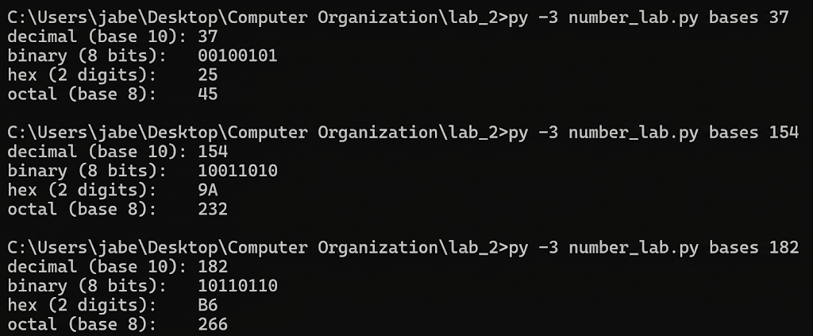

python3 number_lab.py bases 37
python3 number_lab.py bases 154
python3 number_lab.py bases 182
Use your decimal answer for 0xB6 as the argument to the final command. Compare every column with your prediction.

A2 Fraction conversion
Convert 10.625 to binary. Show the repeated multiplication by 2 for the fractional part, then use grouping to obtain hexadecimal and octal forms. Group outward from the binary point.
Decimal | Binary | Hexadecimal | Octal
10.625 | 1010.101 | A.A | 12.5

Working
0.625 × 2 = 1.25 → 1
0.25 × 2 = 0.50 → 0
0.50 × 2 = 1.00 → 1

10.625₁₀ = 1010.101₂
1010.1010₂ = A.A₁₆
001 010.101₂ = 12.5₈

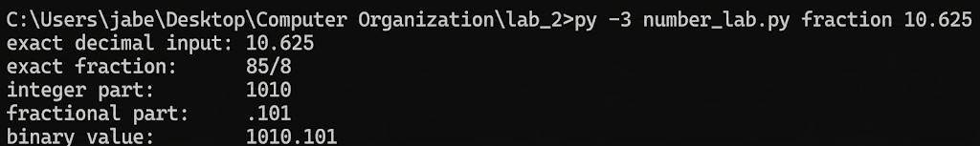

python3 number_lab.py fraction 10.625

A3 Storage capacity
A device must distinguish 1000 different states. What is the minimum number of bits needed? Show the two neighboring powers of 2. How many bit patterns remain unused?
Answer:
- 1 bit = 2¹ = 2 states (0, 1)
- 2 bits = 2² = 4 states (00, 01, 10, 11)
- 8 bits = 2⁸ = 256 states
- 9 bits = 2⁹ = 512 states (Not enough to hold 1000 states!)
- 10 bits = 2¹⁰ = 1024 states (Big enough to hold 1000 states!)

- Two neighboring powers of 2: 2⁹ = 512 and 2¹⁰ = 1024 (since 512 < 1000 <= 1024)
- Minimum number of bits needed: 10 bits (because 9 bits only gives 512 patterns, which is too small, while 10 bits gives 1024 patterns).
- Unused bit patterns: $1024 - 1000 =$ 24 unused bit patterns.

Part B Signed representations
Lecture link Lecture 3b slides 6 to 16 and Lecture 3c slides 8 to 9

B1 Encode and interpret
For each encoding, write the 8 bit representation of -37 and interpret the pattern 10110110. Write NR if a value cannot be represented. In excess 127, encode by adding 127 and decode by subtracting 127.
Encoding | Bits for decimal -37 | Value of 10110110
Unsigned | NR | 182
Sign and magnitude | 10100101 | -54
Ones complement | 11011010 | -73
Twos complement | 11011011 | -74
Excess 127 | 01011010 | +55

Show your working for the twos complement and excess 127 rows.
+37 = 00100101
invert = 11011010
add 1 = 11011011

−37 + 127 = 90
90₁₀ = 01011010₂
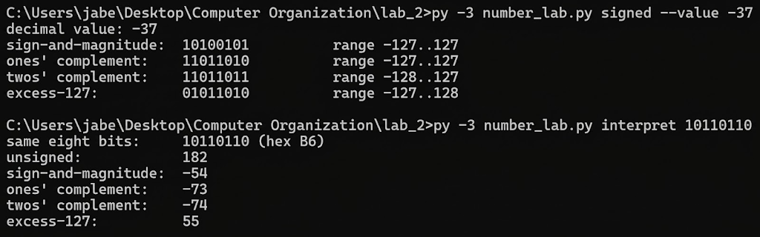

python3 number_lab.py signed --value -37
python3 number_lab.py interpret 10110110
Which encodings have both a positive zero and a negative zero? Which of the listed encodings can represent -128? Explain using the available range.

Which encodings have both a positive zero and a negative zero?
Answer: Sign and magnitude (00000000 is +0, and 10000000 is -0) and Ones' complement (00000000 is +0, and 11111111 is -0).

Which of the listed encodings can represent -128? Explain using the available range.
Answer: Only Two's complement can represent -128 (as 10000000). Because Sign & Magnitude and Ones' complement waste an extra bit pattern on "-0", their range is only -127 to +127. Two's complement has only a single zero (00000000), which frees up one extra pattern on the negative side, giving it a range of -128 to +127. (Unsigned has a range of 0 to 255, and Excess 127 has a range of -127 to +128 because 0 - 127 = -127).

B2 Encoding a value and negating a pattern
Lecture link Number Systems Supplementary Notes slides 2 to 4
These are four different instructions. Keep every answer at 8 bits.
Instruction | Answer
Encode +5 in ones complement | 00000101
Obtain the ones complement of 00000101 | 11111010
Encode +5 in twos complement | 00000101
Obtain the twos complement of 00000101 | 11111011

Which instructions keep the value +5, and which produce -5?
Answer:
- The "Encode +5..." instructions (Rows 1 and 3) keep the value
- The "Obtain the ... complement of 00000101" instructions (Rows 2 and 4) negate the pattern and produce -5

Part B Arithmetic and overflow
Lecture link Lecture 3c slides 2 to 5

B3 Model an 8 bit adder
Encode both operands in twos complement and add the unsigned bit patterns. Keep the low 8 bits and interpret them as a signed value. Carry out is the ninth bit. Signed overflow means the true mathematical sum is outside -128 to +127.
Operands | True sum | Low 8 bits | Stored signed value | Carry out | Signed overflow
96 + 40 | 136 | 10001000 | -120 | 0 | Yes
-70 + (-80) | -150 | 01101010 | +106 | 1 | Yes
96 + (-40) | 56 | 00111000 | +56 | 1 | NO

Show one complete binary addition, including the carry out. State why the stored signed answer is valid or invalid in each row.
−70 = 10111010
−80 = 10110000

0 10111010
+ 0 10110000
--------------------
1 01101010

96 + 40:
overflow without carry out

96 + (−40):
carry out without signed overflow
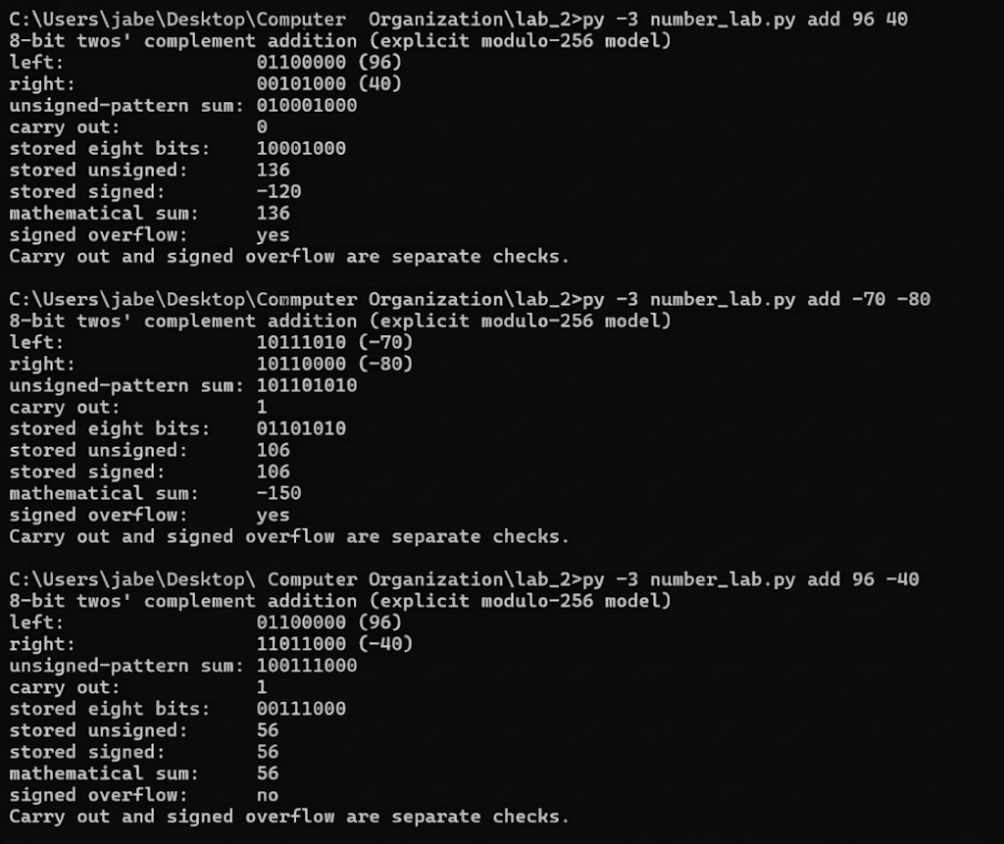

python3 number_lab.py add 96 40
python3 number_lab.py add -70 -80
python3 number_lab.py add 96 -40
Find a row with signed overflow but no carry out, and a row with carry out but no signed overflow. This lab models a bit adder explicitly; it does not assume that overflowing a signed C variable has a portable wraparound result.

Part C Text and interpretation
Lecture link Lecture 3b slides 2 to 4
C1 Encode the text Hi! in ASCII. Use an 8 bit byte with a leading zero for each 7 bit ASCII code. Do not add a parity bit or a string terminator in this task.
Character | ASCII decimal | Hex byte | Binary byte
H | 72 | 48 | 01001000
i | 105 | 69 | 01101001
! | 33 | 21 | 00100001

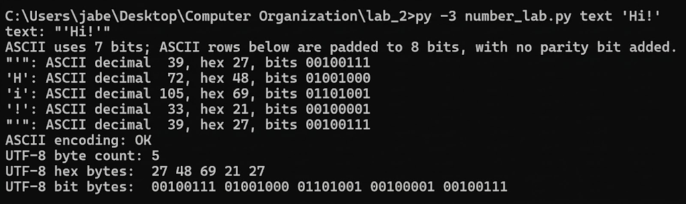
python3 number_lab.py text 'Hi!'
How many character bytes and bits are stored? What does 01000110 mean as an unsigned integer, and what does it mean as an ASCII character?

How many character bytes and bits are stored?
Answer: How to calculate: The string 'Hi!' has 3 characters (H, i, and !), and the instructions state not to add a string terminator. Since each character takes 1 byte (8 bits):
- Character bytes stored: 3 bytes
- Bits stored: 3 * 8 = 24 bits

What does 01000110 mean as an unsigned integer, and what does it mean as an ASCII character?
Answer:
Unsigned integer: 70
ASCII character: F

Part D Fixed and floating point
Lecture link Lecture 3b slide 18 and Lecture 3d slides 2 to 7

D1 Signed fixed point
Use 8 stored bits in twos complement, with 2 fractional bits. The binary point is assumed before the last 2 bits. First interpret the whole byte as a signed integer I, then divide by 4.
$x = \frac{I}{4}$
Task | Answer
Decode the bits 11110101 | −2.75
Encode +5.25 as 8 stored bits | 00010101
Encode -5.25 as 8 stored bits | 11101011
Smallest step between neighboring values | 0.25
Minimum and maximum values | −32 and 31.75

Show the integer scaling used for +5.25 and -5.25. When negating the stored pattern, add 1 at the least significant stored bit.

+5.25 × 4 = 21
21₁₀ = 00010101₂

+21 = 00010101
invert = 11101010
add 1 = 11101011

−5.25 is stored as 11101011₂
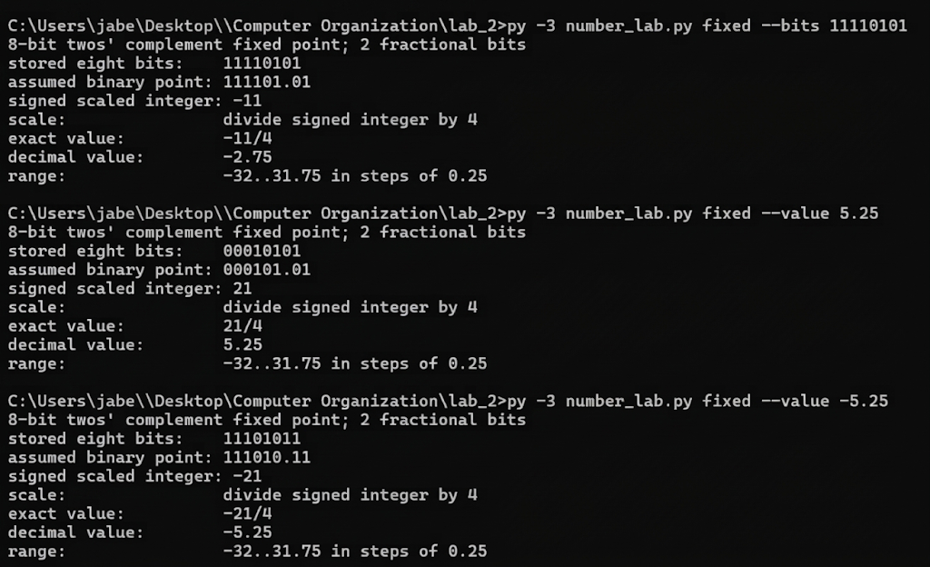

python3 number_lab.py fixed --bits 11110101
python3 number_lab.py fixed --value 5.25
python3 number_lab.py fixed --value -5.25

D2 IEEE 754 binary32
Represent +13.25 in binary32. This task uses a normal, finite value. Binary32 stores 1 sign bit, 8 exponent bits with bias 127 and 23 fraction bits. The leading 1 of the normalized significand is implicit.
Write the binary value and normalize it into the form below. The exponent e is the actual power of 2; the stored exponent is e + 127.
$1.f × 2^{e}$

Sign bit | Exponent bits | Fraction bits
0 | 10000010 | 10101000000000000000000

Hexadecimal bit pattern 0x41540000
What changes for -13.25? Give its hexadecimal pattern and explain whether +13.25 is represented exactly.
13.25₁₀ = 1101.01₂
= 1.10101₂ × 2³
−13.25 hexadecimal pattern = 0xC1540000
Only the sign bit changes for −13.25.
+13.25 is represented exactly because 0.25 = 0.01₂.
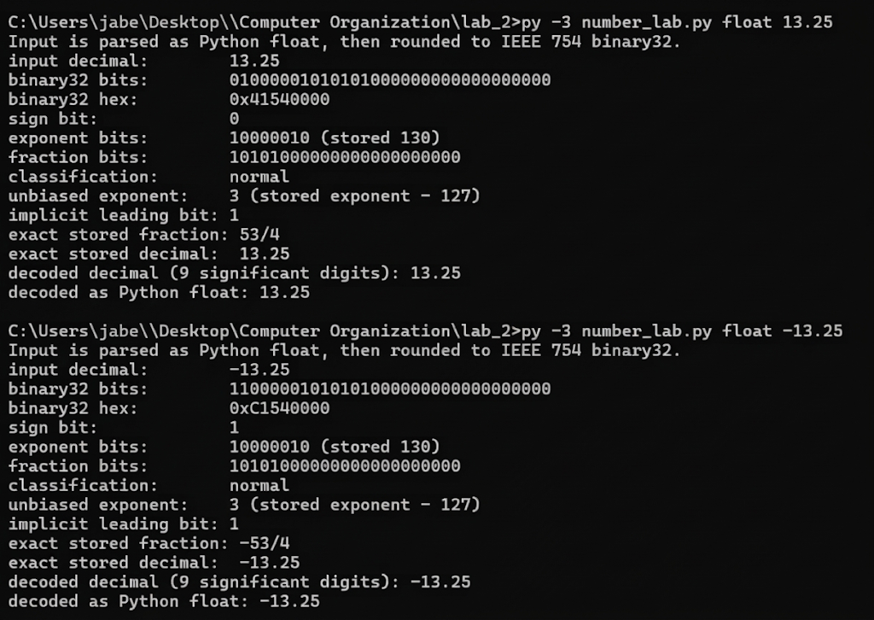

python3 number_lab.py float 13.25
python3 number_lab.py float -13.25

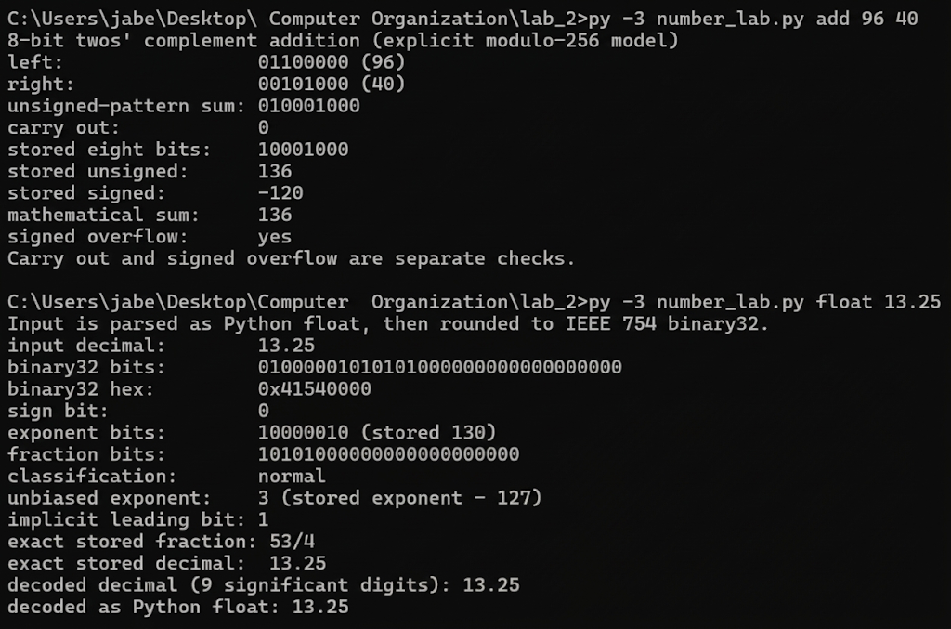

Optional extension tasks
Allow about 30 extra minutes. E1 practices another Lecture 3 arithmetic method. E2 to E4 extend the lecture with text encoding and floating point precision. They are not required for the core submission.

E1 Ones complement addition
Lecture link Lecture 3c slides 6 to 7
In a 4 bit ones complement system, add -2 and -5. Show both operand patterns, the raw sum and the end around carry. Decode the final result and check for signed overflow. Do this by hand; the tool add command uses twos complement.

E2 A character can use more than one byte
Run the following command for the single character é. Record its Unicode code point and UTF-8 bytes. How many characters and bytes are present? Can standard ASCII represent this character?
python3 number_lab.py text 'é'

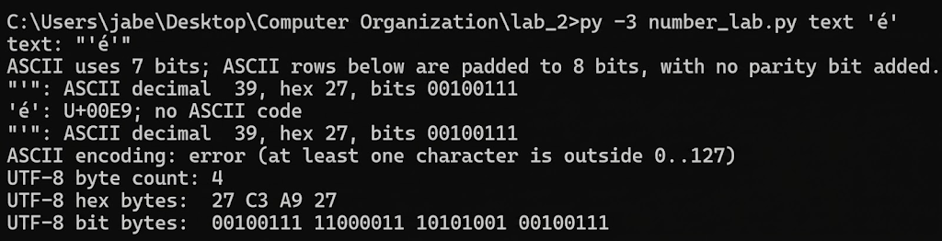

E3 The stored value of 0 point 1
Predict whether decimal 0.1 has a finite binary fraction. Run the command and record the binary32 hexadecimal pattern and the exact stored decimal value. Is it above or below the exact fraction 1/10?
python3 number_lab.py float 0.1
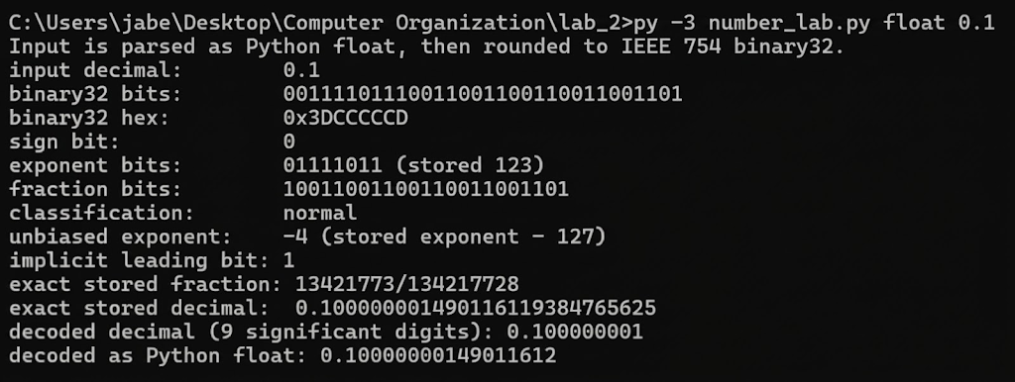

E4 Adding one can leave a value unchanged
The precision command explicitly rounds operands and the result to binary32. Predict the result of 16777216 + 1. Run the command and explain the observation using the spacing of nearby representable values. The tool also shows nearest rounding with ties to even.
python3 number_lab.py precision

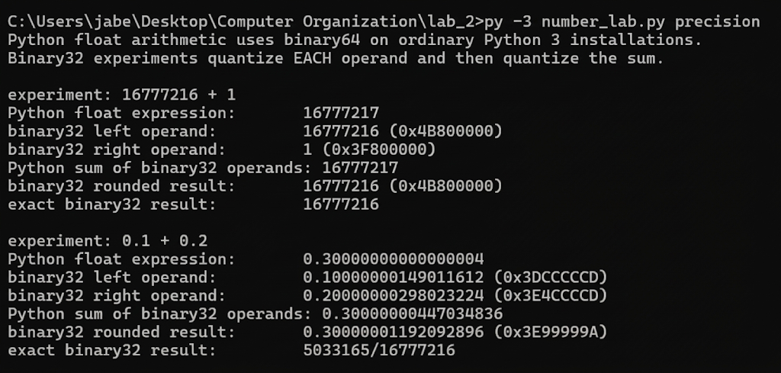

Exit questions and submission

Exit questions
1. A byte contains 10110110. What information is needed before you can say what value it represents? Give two interpretations from Part B.
Answer: What information is needed? You must know the encoding/representation scheme being used (whether the byte is treated as unsigned, signed two's complement, sign-and-magnitude, etc.). Without knowing the encoding rules, the exact same bit pattern 10110110 can mean completely different numbers.

Given two interpretations from Part B
- Unsigned integer: Evaluates to 182.
- Two's complement signed integer: Evaluates to -74. (Other valid interpretations from Part B include -54 for sign-and-magnitude, -73 for ones' complement, or +55 for excess 127).

2. Use a Part B example to explain why carry out and signed overflow are different.
Answer: A carry out is simply an extra 9th bit generated by the leftmost column during binary addition, whereas signed overflow occurs when the true mathematical sum falls outside the valid 8-bit two's complement range of $-128$ to $+127$. They are completely independent phenomena.

Given two examples from Part B
- In the addition 96 + (-40), there is a carry out (the 9th bit is 1), but there is NO signed overflow because the true sum (+56) easily fits within the valid range.
- Conversely, in 96 + 40, there is NO carry out (the 9th bit is 0), but signed overflow DOES occur because the true sum (+136) exceeds +127, causing the result to wrap around into -120. This proves that carry out and signed overflow do not imply each other.

Submit your work
Submit one PDF named Lab2_StudentID.pdf containing your completed core tables, working and exit answers. Include one screenshot of the add 96 40 command and one of the float 13.25 command. Each screenshot must show the command and output. Add optional extension answers only if you attempted them.
Check that every bit pattern has the required width and every numeric answer identifies its base or encoding. For a corrected prediction, keep your original answer visible and explain the correction in one sentence.

Assessment
Core task | Marks
A Conversions and capacity | 4
B Signed encodings and arithmetic | 6
C ASCII and interpretation | 2
D Fixed point and binary32 | 6
Exit explanations and evidence | 2
Total | 20

